End-to-end data analysis project

**Outline**

* This analysis project will answer you some important questions and why:
  + Film making trend between TV/Show and Movie
  + Which genres are most favored by audiences
  + Which country produced most films
  + What is the average duration of a movie/TV Show and its trend
  + In some countries, which genres are their advantages
  + Which audience target that film makers heading to

The end-to-end data analysis project

Business problem (define problems)-> Collecting the data -> Cleaning the data -> Analyze the data -> Building predicting model(optional)

Business problem: this is the stage where you define the problem, what is the problems. For the Netflix Movie/TV-Shows use case. It could be the director want to make a film. He wants to see whether his film would be successful on his country or should the company invest the money to produce a film at the present or waiting till the right time. The analysis of data will

maybe answer your question.

Collecting the data: having understand the problem. Now you need data to help you answer your question. If you are working on company, I think they will provide a hostname/password to connect to database and take out the data. Or if you are unemployed or still being an undergrad student. You can just go to Internet and collect data.

In this case, I will use Netflix Movies/TV-Shows dataset from Kaggle.

[Netflix Movies and TV Shows | Kaggle](https://www.kaggle.com/datasets/shivamb/netflix-shows)

Cleaning data: in this step, I will change handle missing data, change the datatype into right format. Change the format of column. In my opinion, this step is very time-consuming.

Analyze the data: in this step, there are 5 category of analysis, including:

Exploratory analysis: over view of data, number of rows, cols.

Descriptive statistic: compute the mean, median, mode, correlation

Predictive analysis: building model to predict future value

Diagnostic analysis: root cause of the problem

Prescriptive analysis:

Film making trend between TV/Show and Movie: let see the number of movies:

It is obvious that number of Movie larger than TV show.

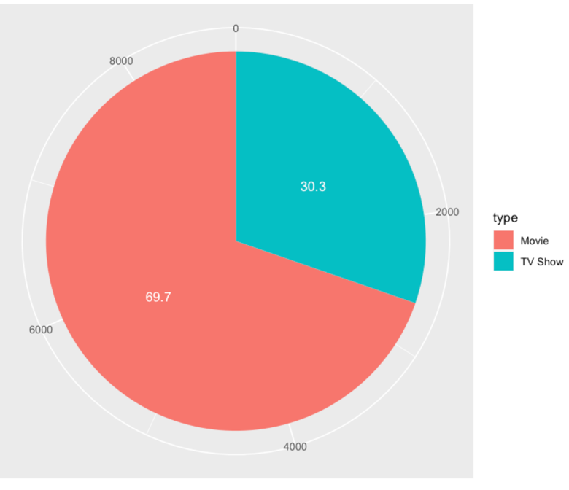

The question is why people tend to make film rather than TV/ Show?

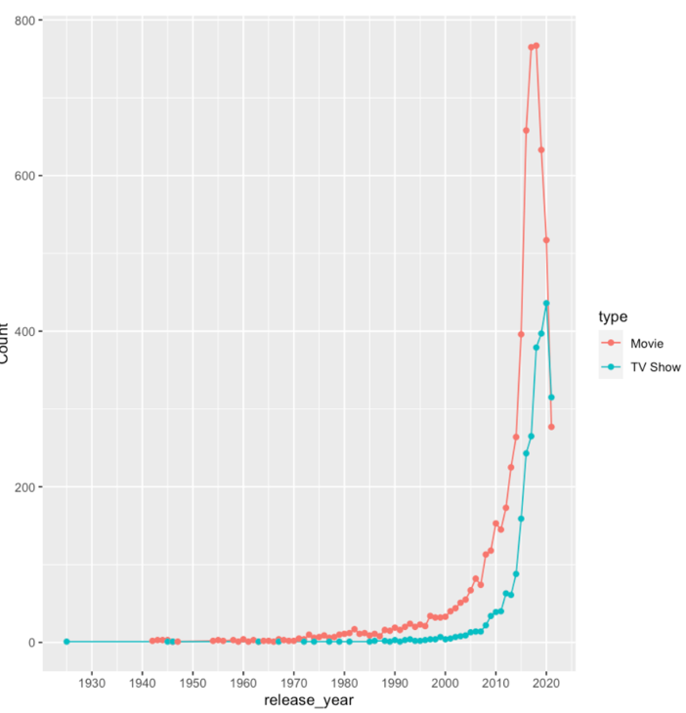

The trend of making film start in about 2000s. When the world step into digital era. Interestingly, the first film was belong to TV Show (1925). The bomming really start after 2010. The first movie was made at 1942. After that TV/show is not produced regularly. In contrast, Movie was made 2-3 movie each year. The reason for that is Movie was easier to make than TV/Show since the time taken to film and make script is shorter.

From this graph, you can see there is a drop at the year 2018. Let plot it:

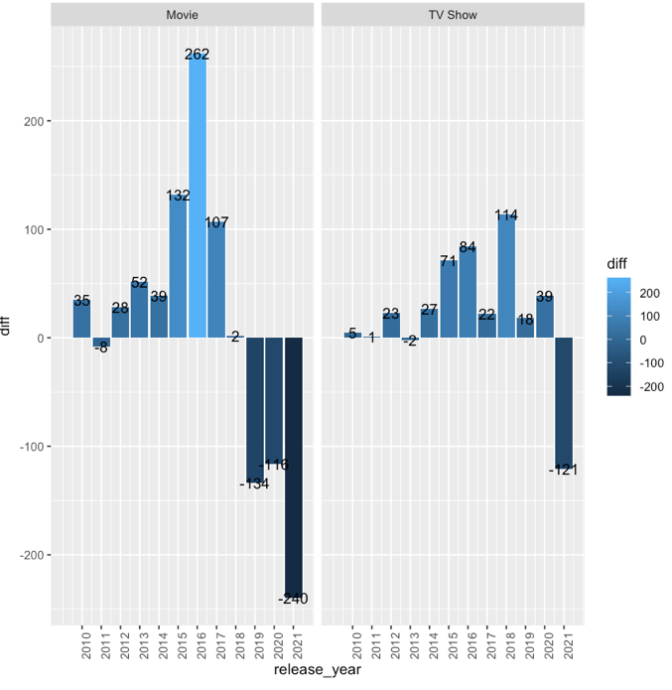

The trend of making movie start from 2016. When there are 262 movies made in just 1 year. The trend soon decrease in just 1 year later. In the year 2018, TV/show the number of film made larger than Movie. From the years 2018 to 2021, both Movies and TV/show quantity was decreased badly due to Covid-19, especially in the year 2021.

In conclusion, I thinks the growth of movie is the benefit it got is larger than when investing to TV/show.

But later on 2018. Audience tend to prefer tv/show because of many reasons but I think the most impact ones is the flow of story.

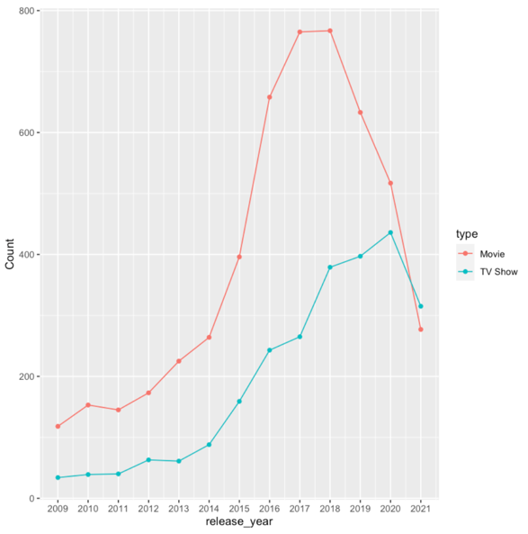

Look at this graph, from 2018 to 2020. The trend of making TV-Shows is larger than Movie.

Which country contribute most to Movie and TV/Show.

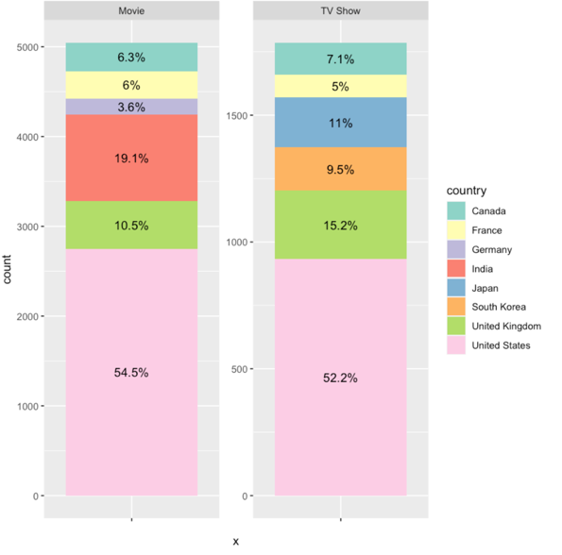Beside US, UK, France and Canada which consume large proportion in both Movie and TV Show. We also have Japan, South Korea strong in TV/Shows and India strong in Movies.

From this plot, you can see that US contribute most films. But over ~24% of their film were from collaboration.

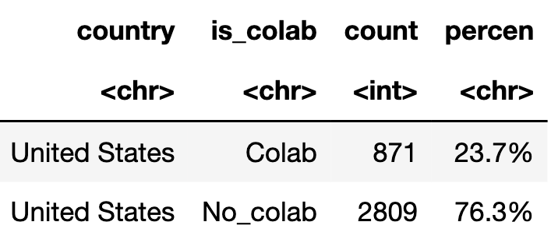

Which genres are most favored by audiences in the world:

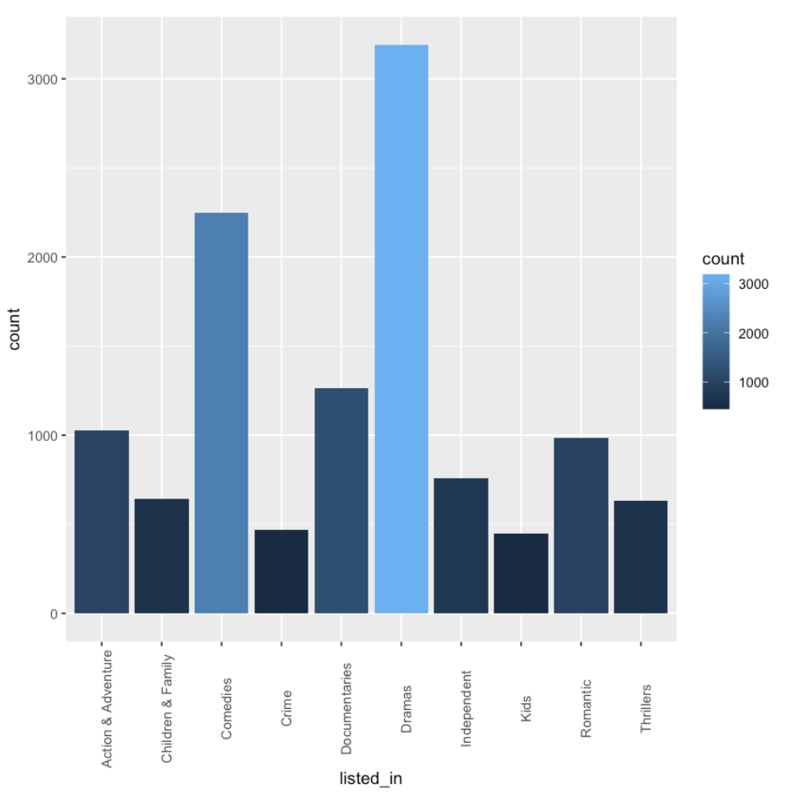From this graph, Drama, Comedies are two of the most favorite genres all over the world, followed by Action & Adventure, Documentaries and Romantic. All of above genres are belong to entertaining category, beside Documentaries(Research and Educational film).

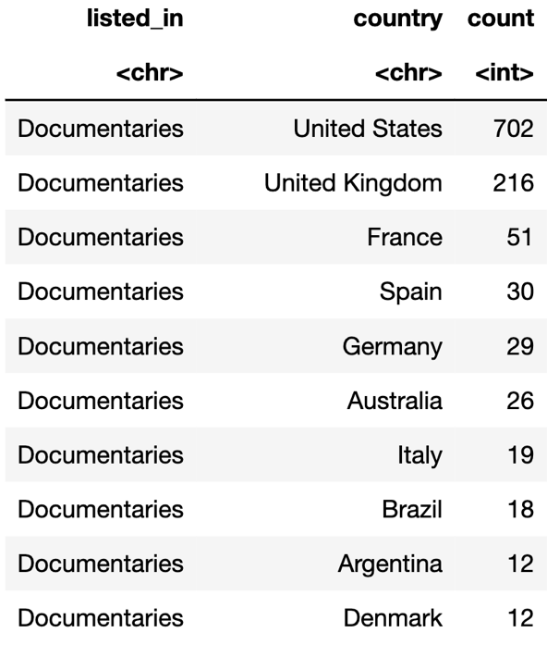

In some countries, which genres are their advantages:

In Japan:

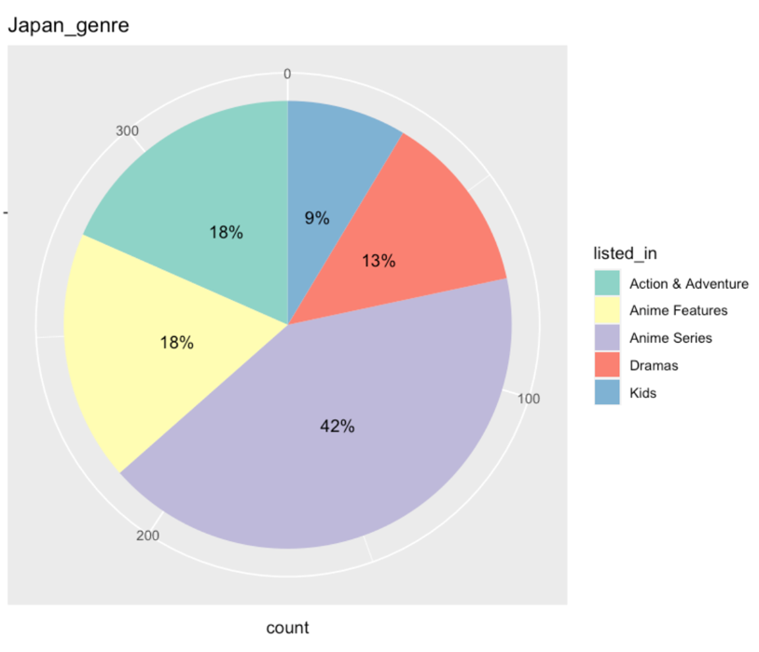

Beside common genres, Anime is specially popular in Japan.

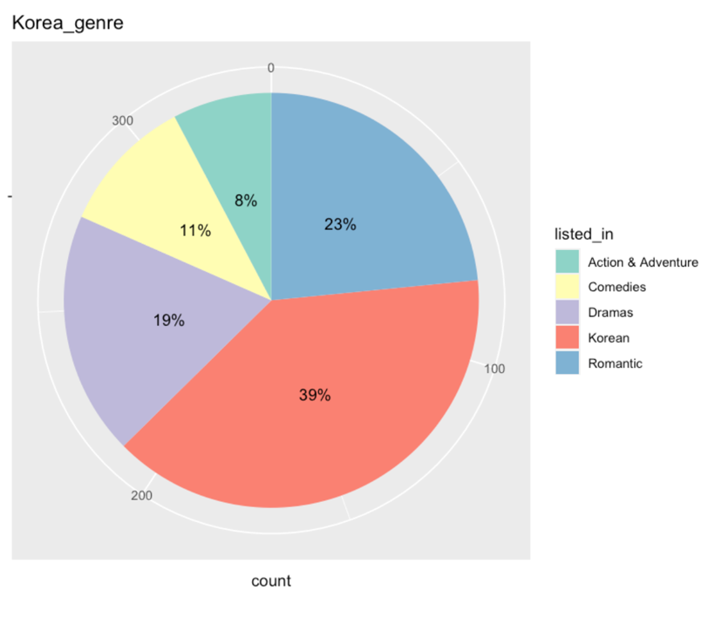

People in Korean tend to watch their movie, another type which popular on Korea is Romantic movie.

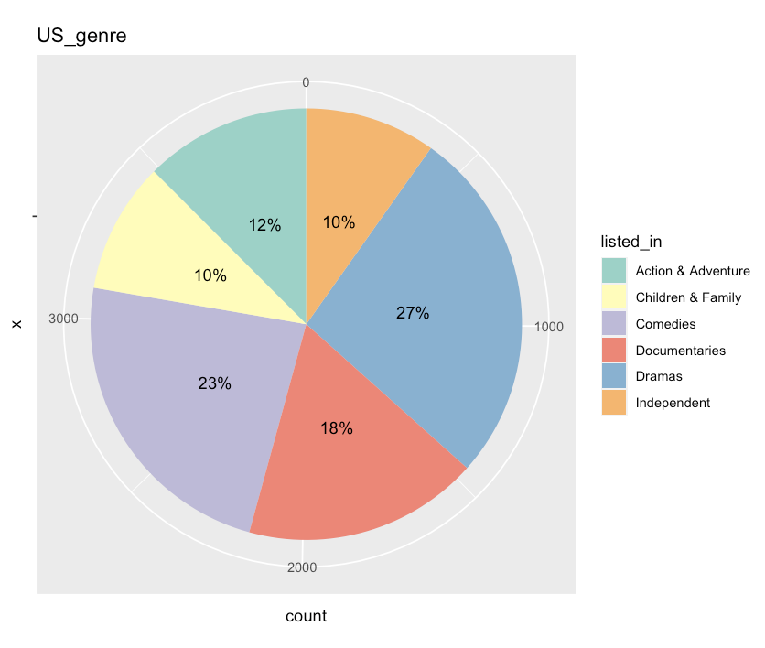In US, Documentaries and Independent movie is two advantages genre of US.